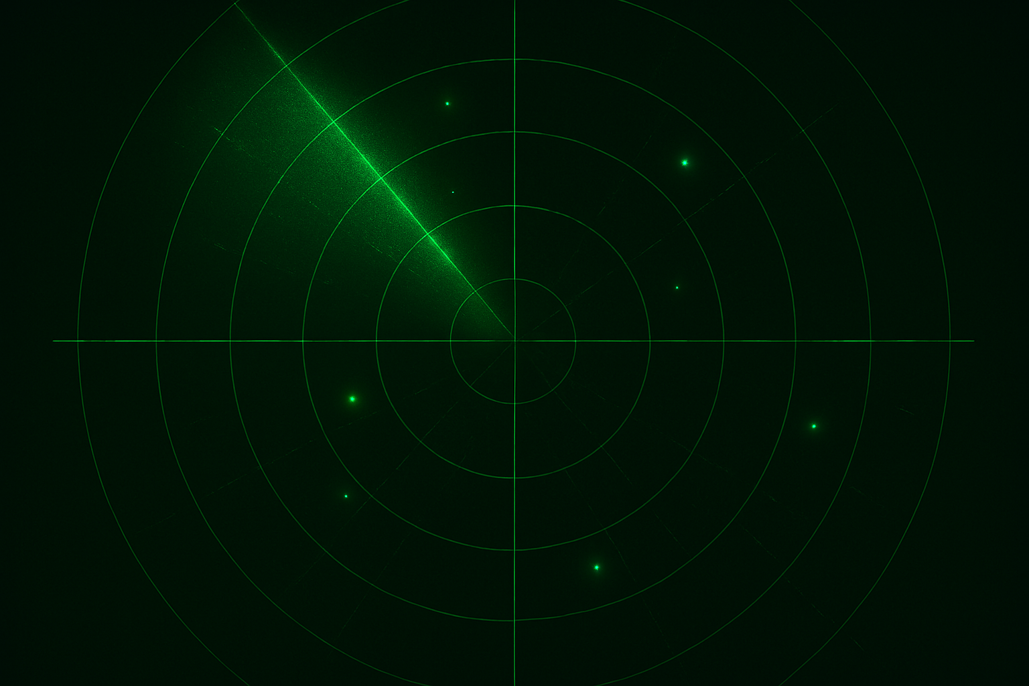

We intercepted this signal file, and we are not sure what it means? But we’ve confirmed that understanding its “Rhythmic beeps” would give a clue. Also, during the intercept, it came with a message “Look for order” hmm possibly has something to do within the file data.

Perhaps your forensics skills could discover something? Good Luck!

